MySQL Assignment 2 – Querying Data
- The previous SQL assignment 1 (database & table creation with constraints).

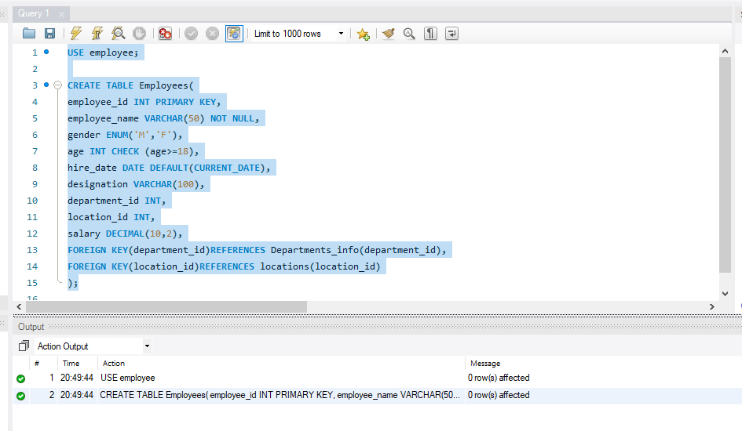

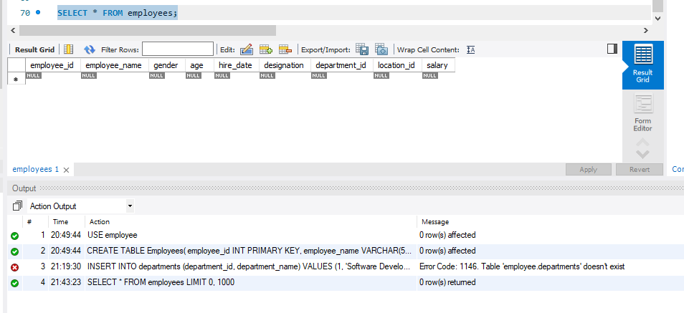

- Select database

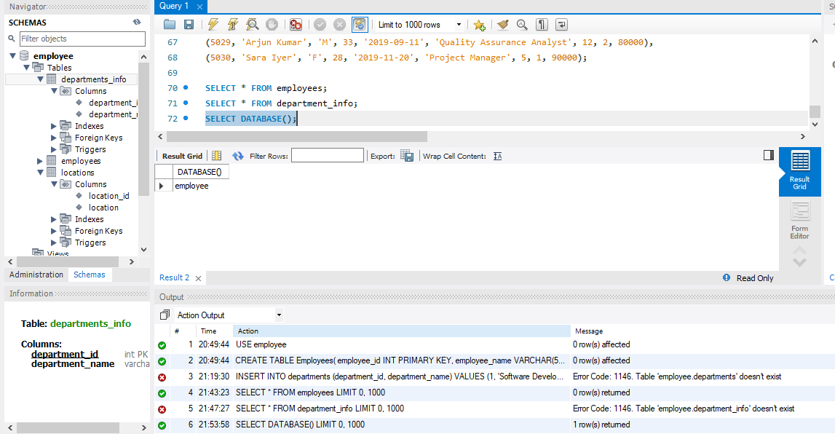

SELECT * FROM department_info;
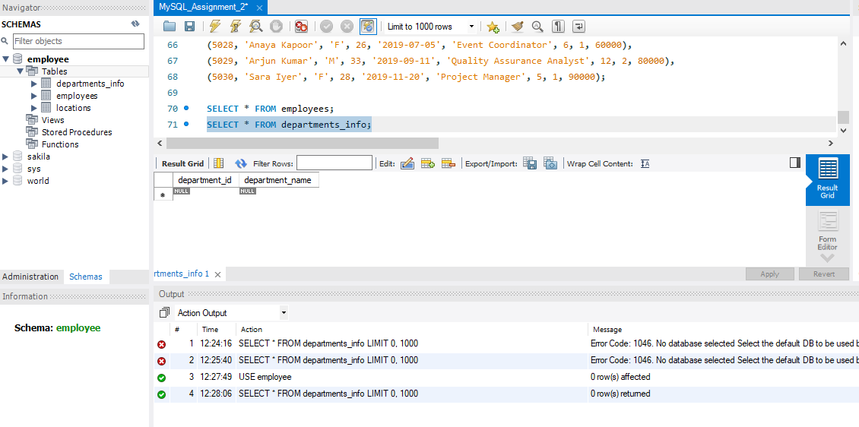
SELECT * FROM locations;

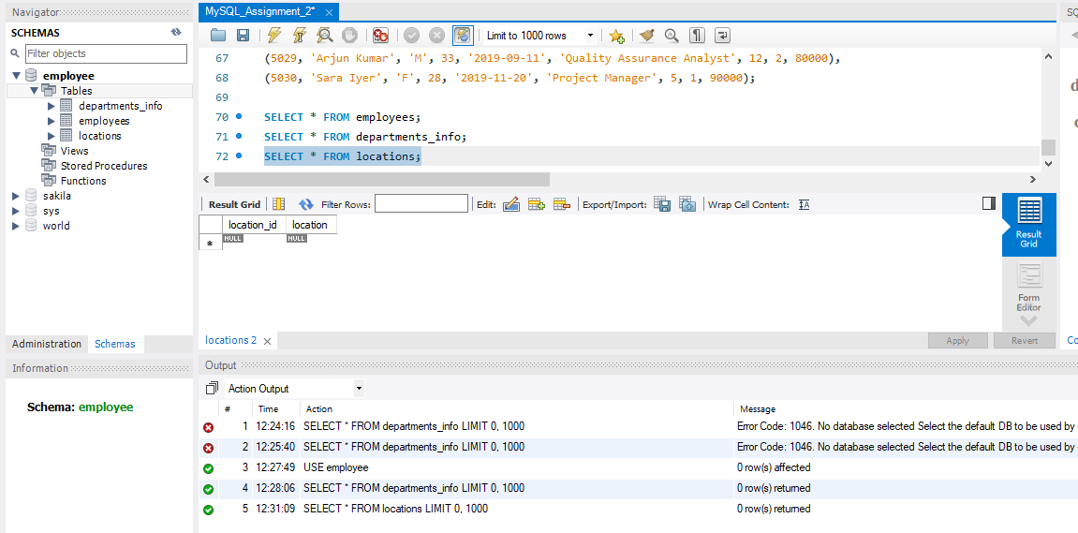

SELECT * FROM employees;
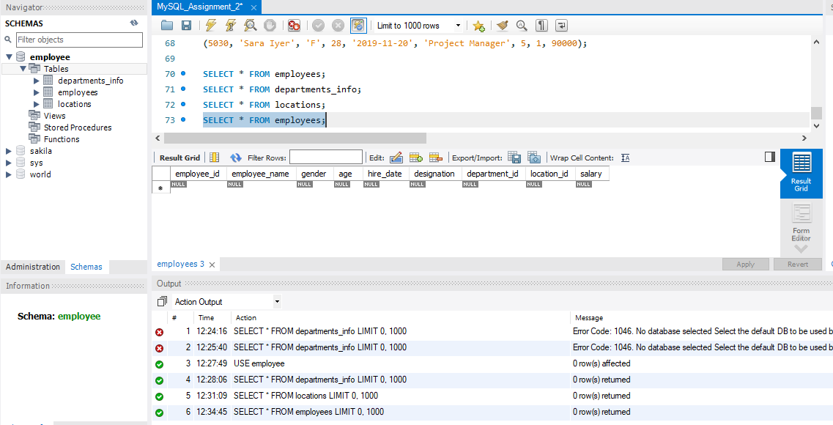

- Use the provided DML insert codes to populate the tables from here: Employee Data

- Insert into department_info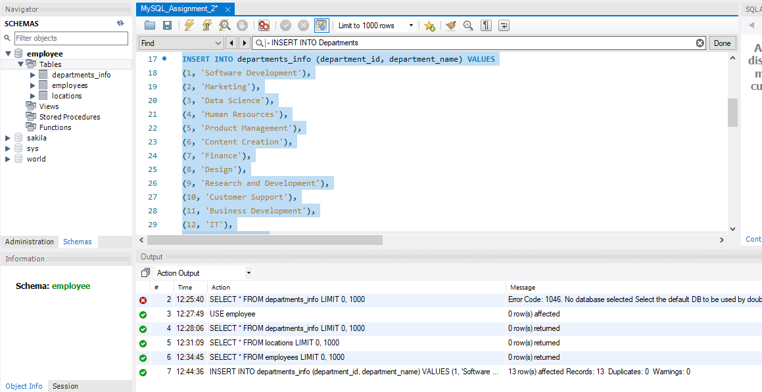

- Insert into locations

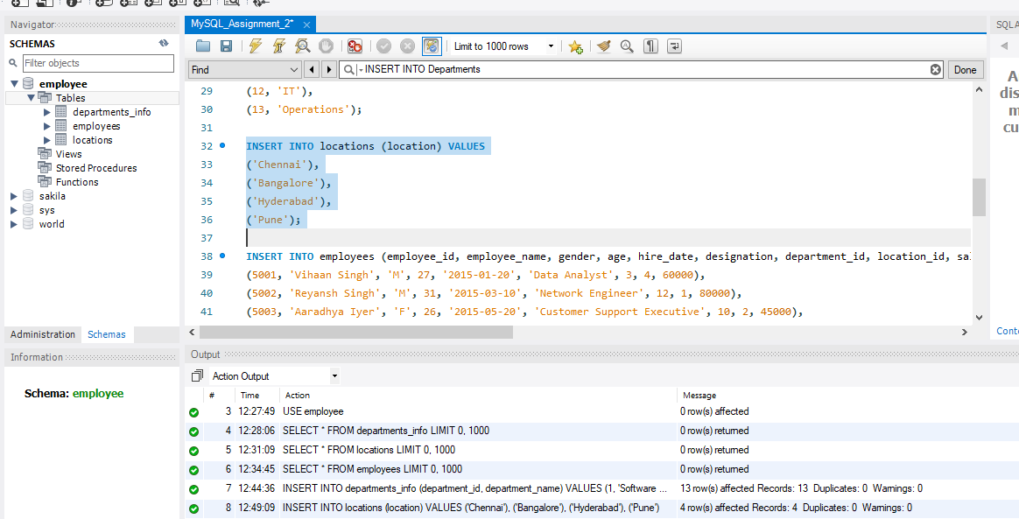

- Insert into employees

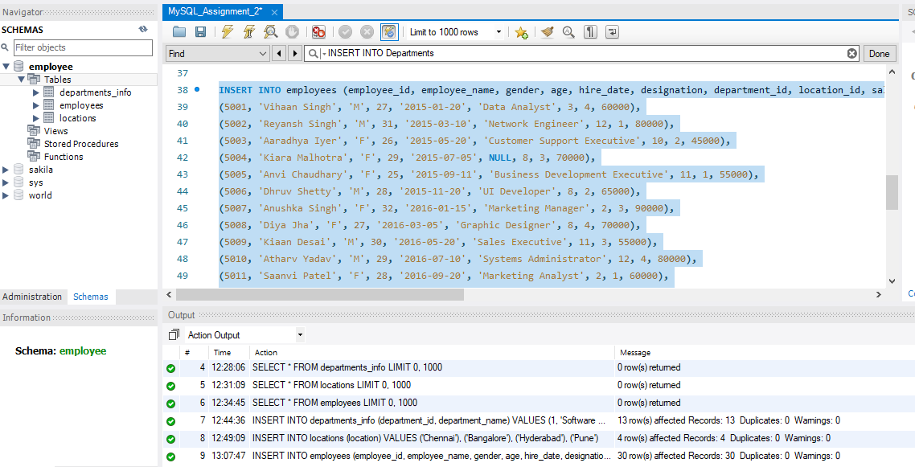

Execute the queries

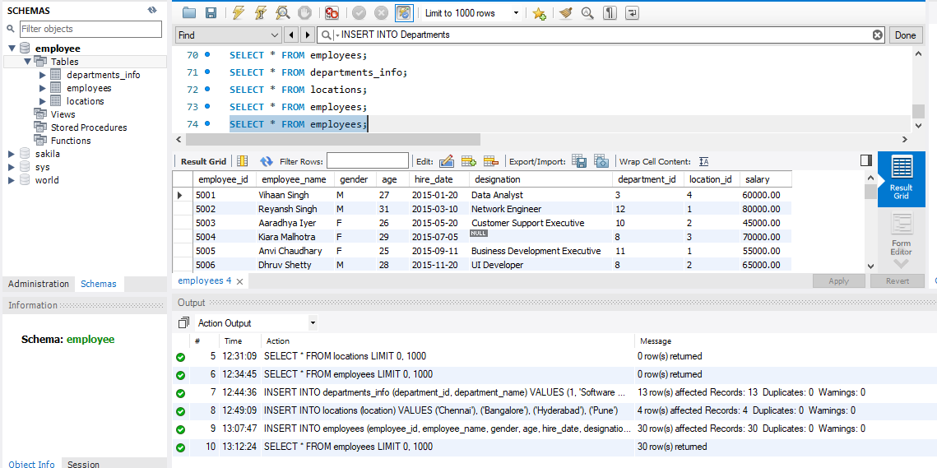

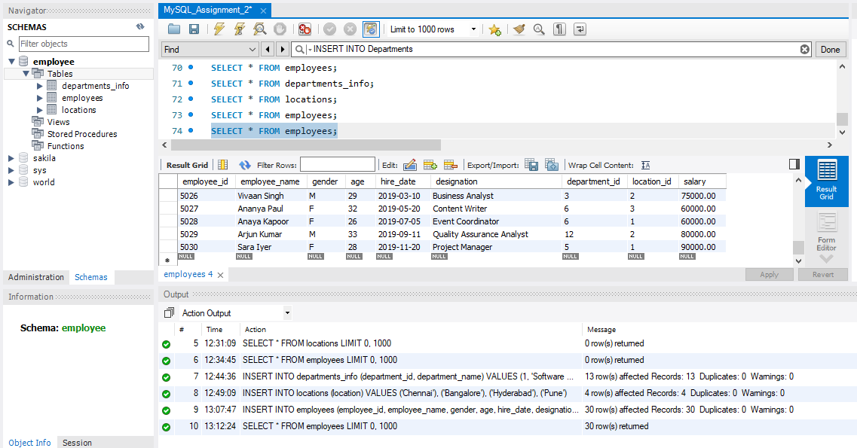

1. Distinct Values:
- A query to retrieve distinct salaries from the Employees table.

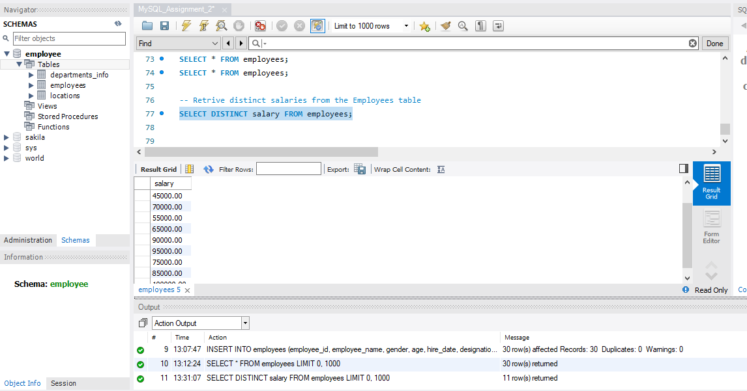

2. Alias (AS):
- Provide aliases for the "age" and "salary" columns as "Employee_Age" and
"Employee_Salary".

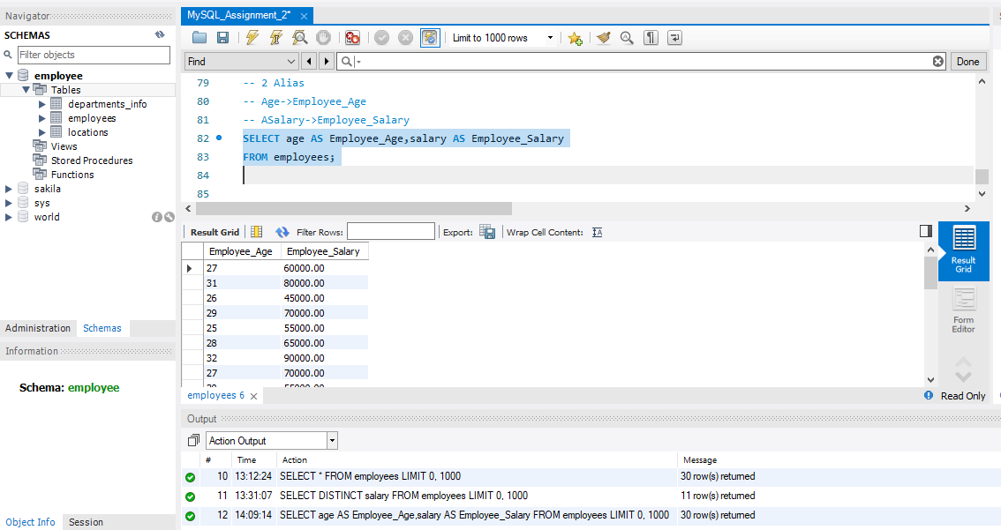

3. Where Clause & Operators:

- 3(1) Retrieve employees with a salary greater than ₹50000 and hired before
2016-01-01.

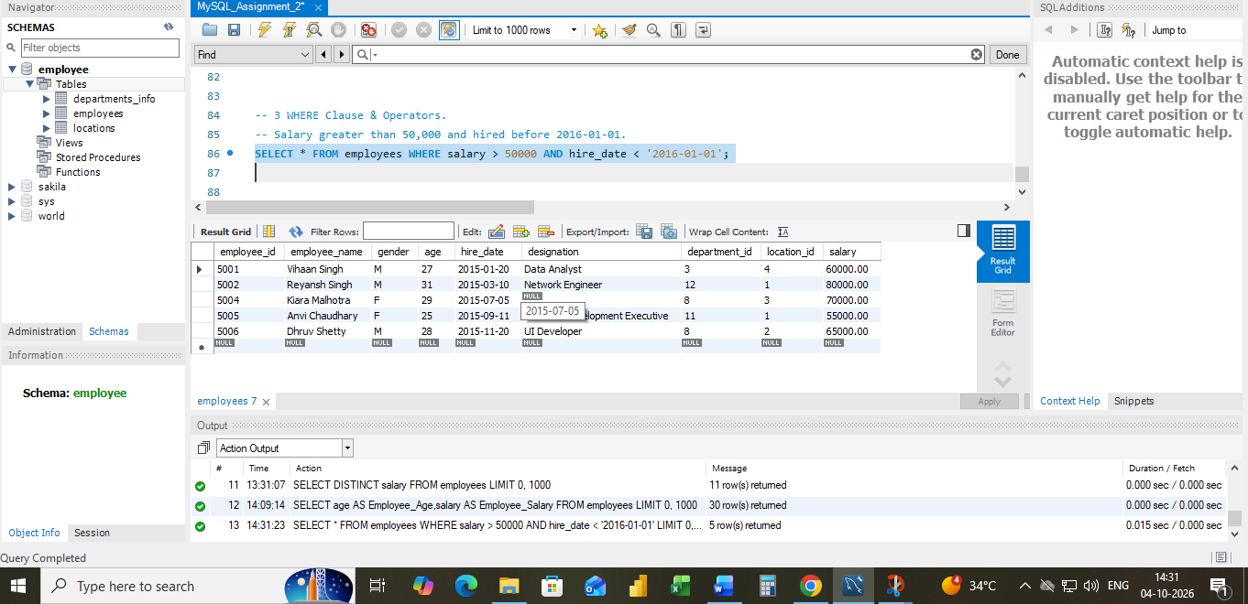

3 (2)Find the employee whose designation is missing and fill it with "Data
Scientist".
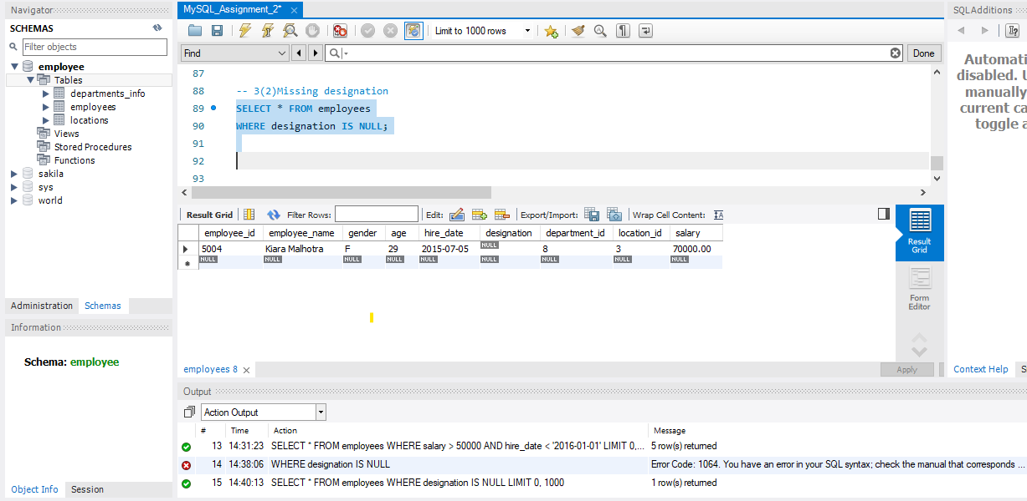

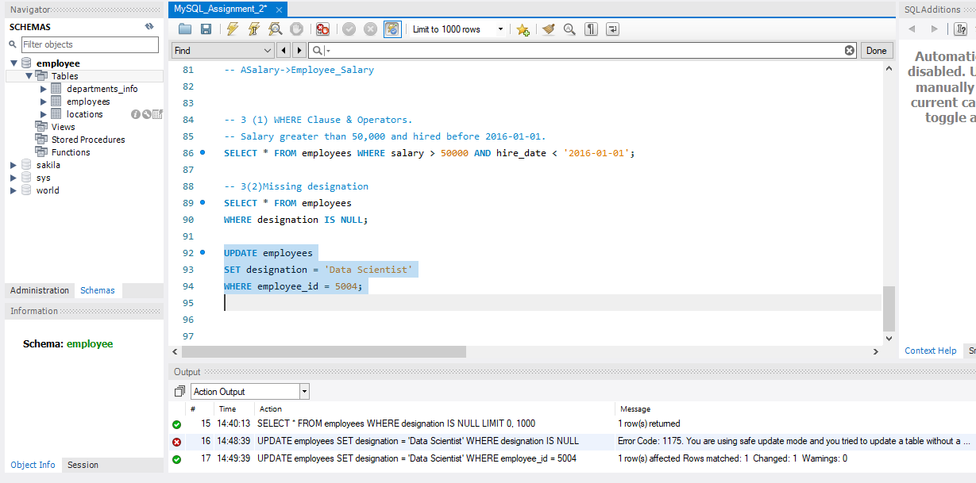
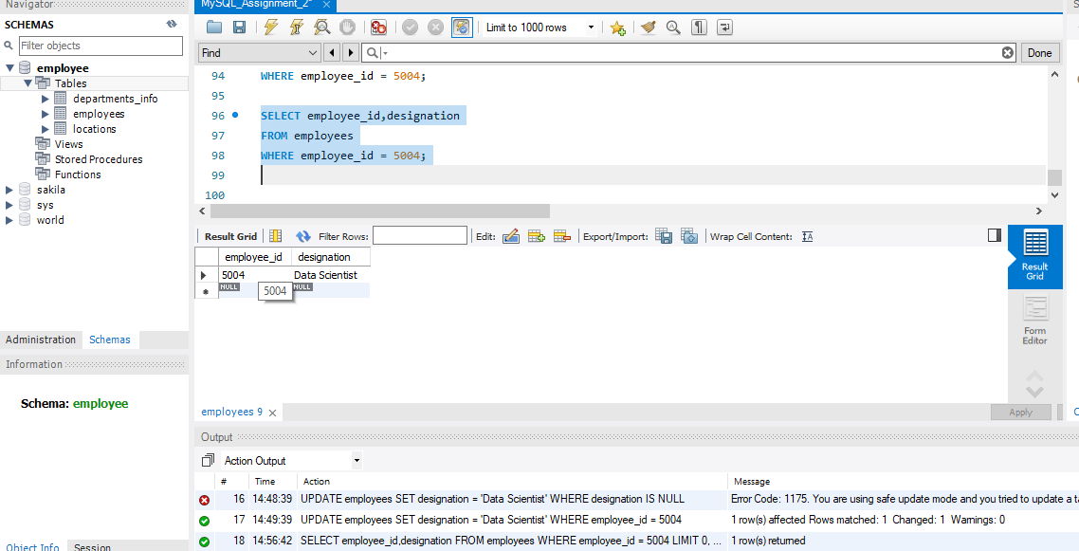

Sorting and Grouping Data:
1. ORDER BY:
Employees sorted by department ID in ascending order and salary in
descending order.
- Department_id ASC department id - small to big
- Salary DESC – one department id salary big to small.

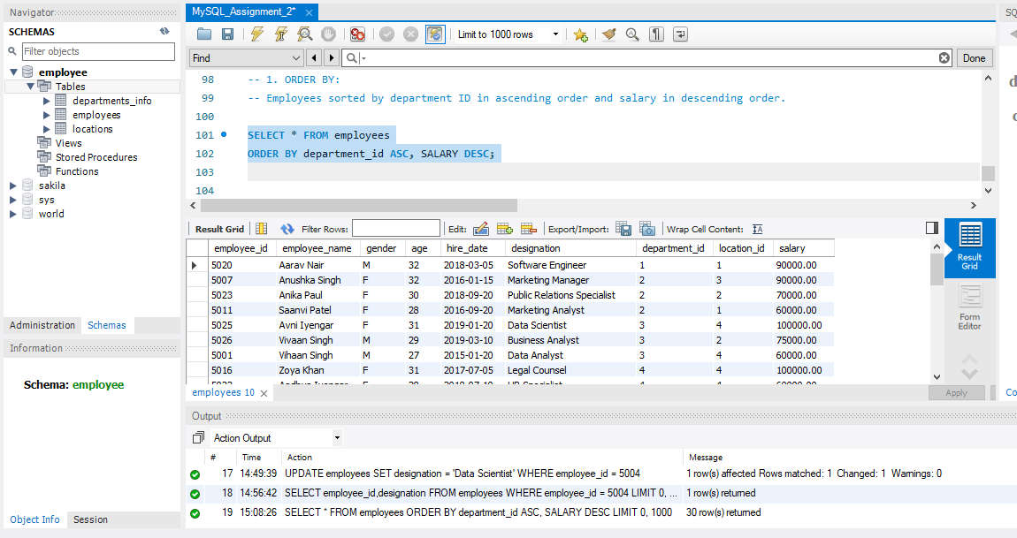

2. LIMIT:
Display the first 5 employees hired in the year 2018.

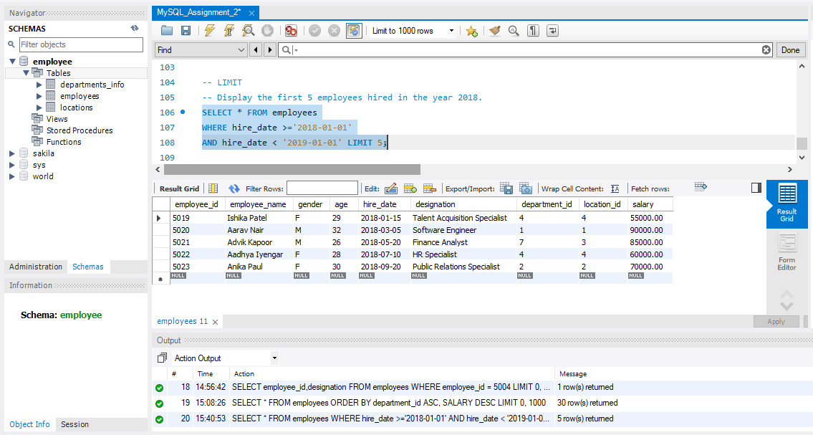
3. Aggregate Functions:
3(a)Sum of all salaries in the Finance department.
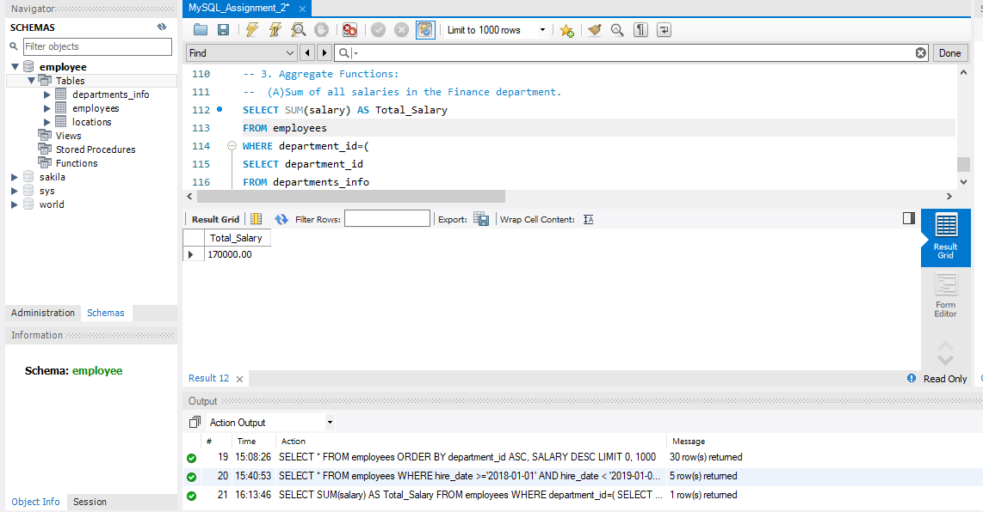
3(b) Minimum age among all employees.
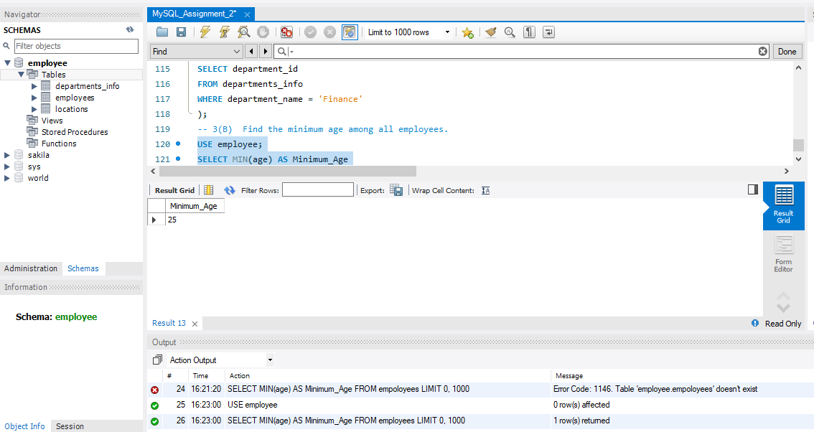

4. GROUP BY:
(a)Maximum salary for each location.

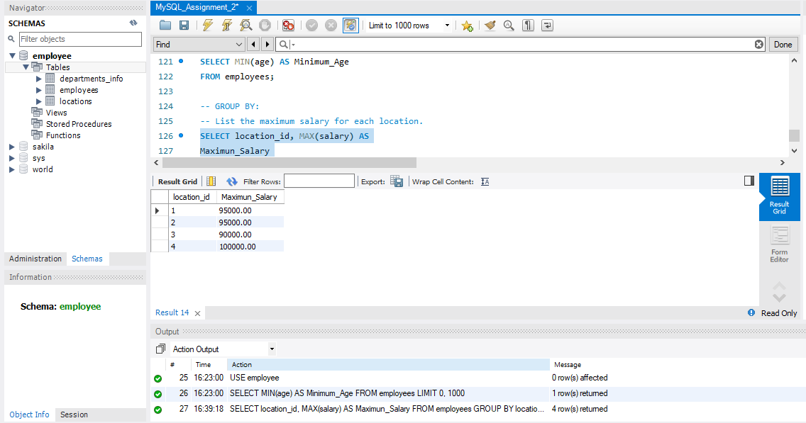

(b) Calculate the average salary for each designation containing the word 'Analyst'.
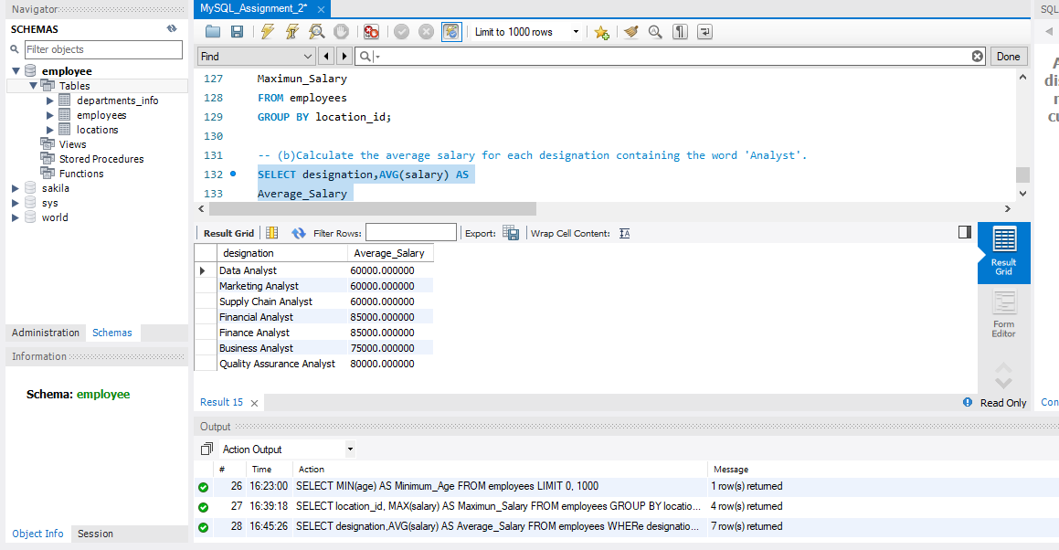

5. HAVING:
(A)Find departments with less than 3 employees.
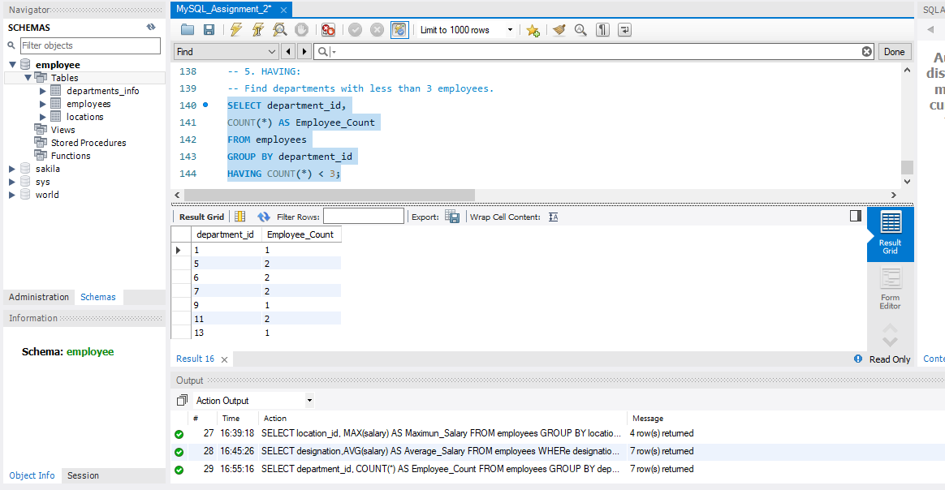

(B )Find locations with female employees whose average age is below 30.

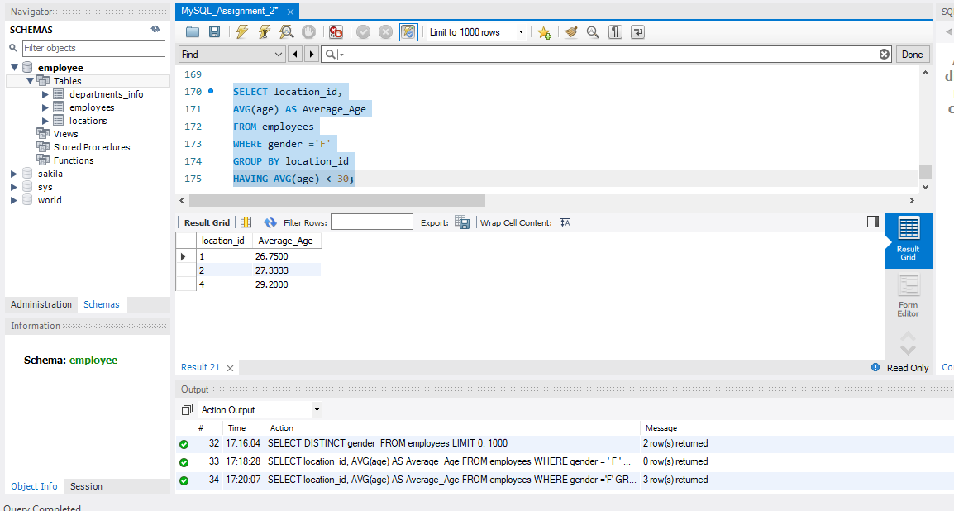

Joins:
- Inner Join:
List employee names, their designations, and department names where employees are assigned to a department.

    - From employees -> e
    - e.employee_name Employees table in employee name
    - e.designation employees table in designation
    - e.department_id – employees table in department ID
    - departments_info -d- table short name

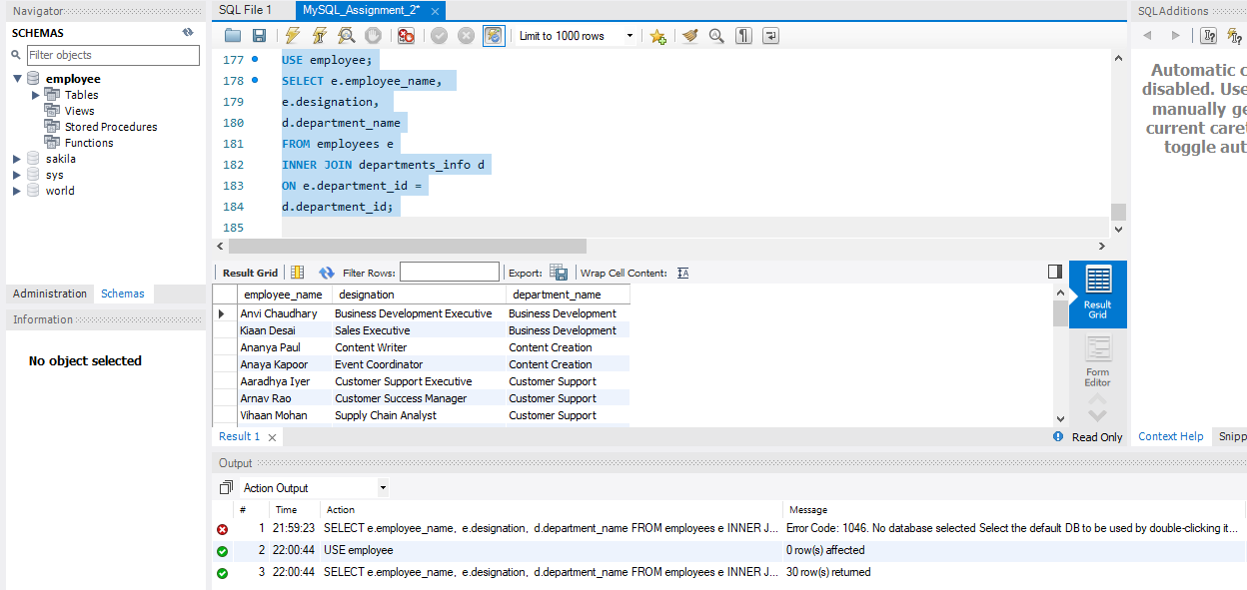

- Left Join:
List all departments along with the total number of employees in each department, including departments with no employees.

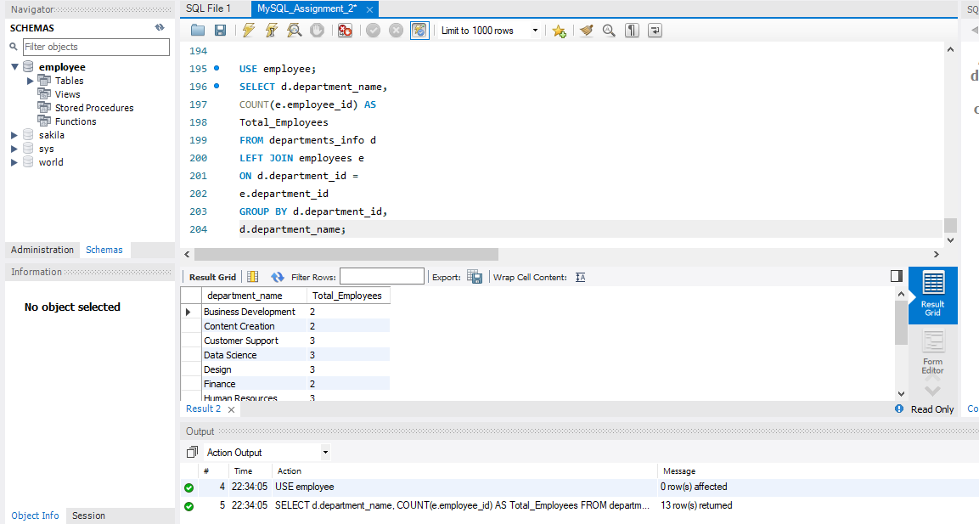
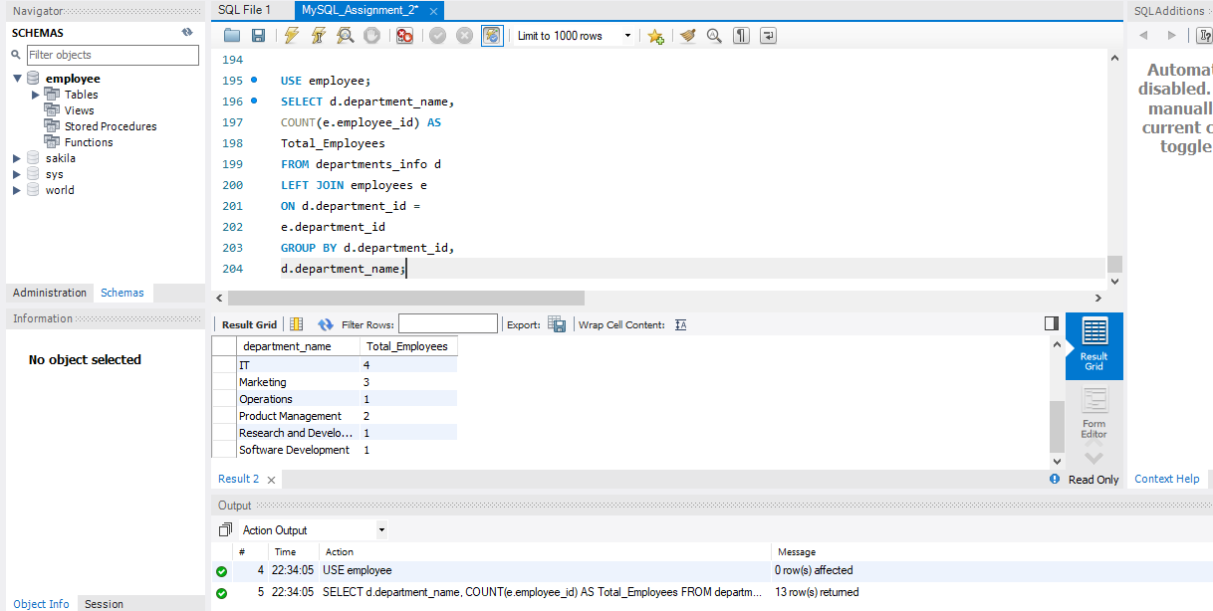
- Right Join:
Display all locations along with the names of employees assigned to each location. If no employees are assigned to a location, display NULL for employee name.
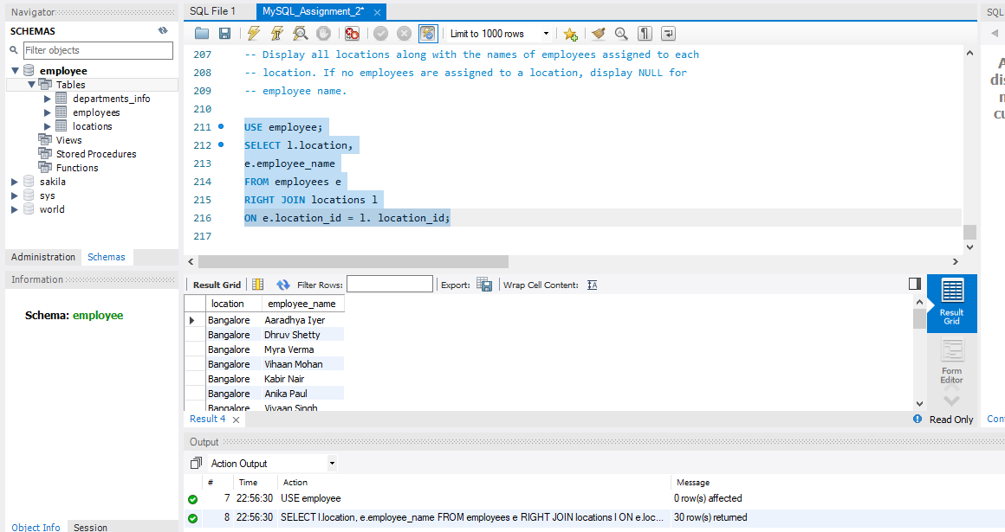

    - l.location_id-locations table
    - e.location_id-employees table
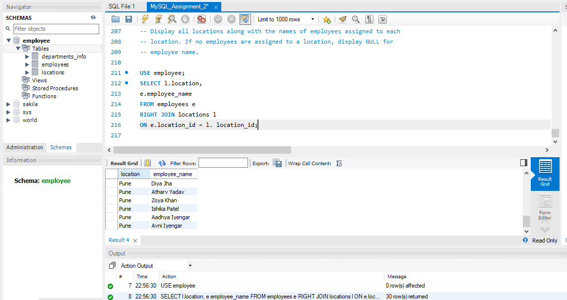
CONCLUSION:
In this assignement , I practiced SQL commands including filtering,sorting, aggregate functions, grouping, HAVING clause , and different types of JOINS. I learned how to retrieve, organize , and analyze employee data using MySQL.

